**Flash cards** are used as a practice tool for **memorization**.

One side of a flash card contains Question and the other side contains the associated Answer.

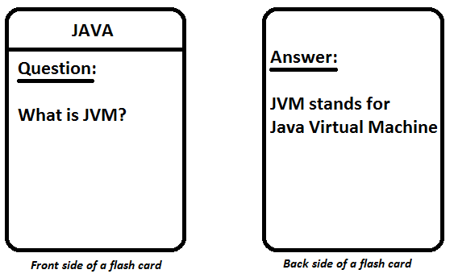

**Case Study:**

Implement a fully functional set of Flash cards, where user can ask for a card of particular subject and then a flash card should show up. The cards shown should be random. Give the user a chance to look at the card and then after a delay of 5 seconds, display the answer.

**Topics Coverage:**

* Classes/ Inheritance
* Getter/Setter
* Exception Handling
* Thread
* Collections
* File I/O

**[ Day 2 ]**

Create class **FlashCard** having following members

private String subject;

private String question;

private String answer;

* Create corresponding Getters/Setters.

**Accept data for 5 flash cards from user (Store them in an array)**

**Display the data back to user, sorted on the basis of subject**

**[ Day 3 ]**

Create **abstract** class **Card** having following members

private String subject;

private String question;

private String answer;

* Provide the getters and setters.

Create interface **CardSearchable** having following method

* Card searchCard(String sub);
* This method will search the cards with given subject

Modify the class **FlashCard** to extend **Card**

* Declare a parameterized Constructor for this class
* There should a way to set/get FlashCard object’s data.
* Create a method displayCard() which will display current card’s data

Design a class **FlashCardsData** whichimplements the **CardSearchable** interface

* It has array of **FlashCard** as a **instance member**

Design a class **FlashCardTest which will have the main method**

* **In the main()**
  + **create a FlashCardsData object**
  + **Accept data for 5 cards from user**
  + Accept a subject to be searched, and display one card of that subject [make use of the searchCard()]

**[ Day 4]**

Implement Exception handling for following:

* If the subject to be searched if not found, then instead of returning null, the method searchCard() should throw an user defined exception called **CardNotFoundException**
* Create a class **CardNotFoundException.** It should display a message saying **– “The card you are looking for is not available”**
* Handle this exception in main() [ at location where you call the searchCard() ]

**[ Day 5 ]**

Create a class **DisplayThread** [extend Thread]**,** whichwilldisplay all the cards read from user. This displaying will be done by instantiating the DisplayThread class and starting the thread.

* All cards should be displayed with a delay of 1 second

**[ Day 6 ]**

Replace the array present in **FlashCardsData** by a **ArrayList**

ArrayList<FlashCard> myCardsList ;

* Make necessary modifications to the code to make it work using ArrayList.

**[ Day 7 ]**

Create a file manually on your hard drive – “cards_data.txt”. It will be having following format/data

java;What is JVM?;JVM is Java virtual machine

java;What is JDK?;JDK is Java development kit

oops;What is a class?;A class is a blueprint for an object

java;Strings are immutable?;True

oops;OOP stands for?;Object oriented programming

Write a method **loadData()** in **FlashCardsData** andread all the data from the above file

[NOTE: Do not accept cards data from user anymore, just load it from the file]

* Accept subject from user
* Search for a random card from the ArrayList
* Display the card to the user
* After a delay of 5 seconds, display its answer.